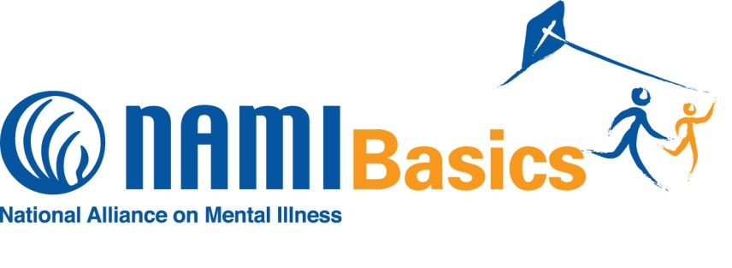

**FEATURING**

**OUR**

**BRAND NEW CURRICULUM**

**Is your child on an IEP?**

**Is your child angry, sad, anxious, acting out or withdrawn?**

**Are you concerned about how your child is behaving?**

**Has your child been diagnosed with ADHD, Conduct Disorder or other emotional problems?**

**ARE YOU HAVING A PROBLEM UNDERSTANDING AND COPING?**

**You’re not alone. NAMI Basics is for you!**

NAMI Basics is a free 6 week education program for parents and caregivers of children and adolescents living with emotional and behavioral issues.

You will learn: **communication tips, how to problem-solve and skills to help you cope with the emotional impact of caring for your child.**

**You will find out about the IEP process, insurance, benefits, diagnoses and treatment.**

For more information please visit: <http://namimass.org/programs/nami-basics>

The course will be held at **Franciscans Hospital for Children** from **1:00 – 3:00pm** on:

**December 4th, 11th, 18th,**

**January 15th, 22nd and 29th**

This program is FREE to participants. **Preregistration is required—space is limited.**



**“This course is inclusive of almost all aspects of child and family resources. I could have spent a lifetime getting all this information on my own. I feel supported, strong and ready to go forward”**



**“This is such a great step-by-step program which walks parents every step of the way”**

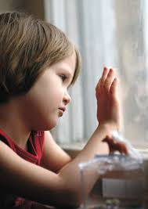

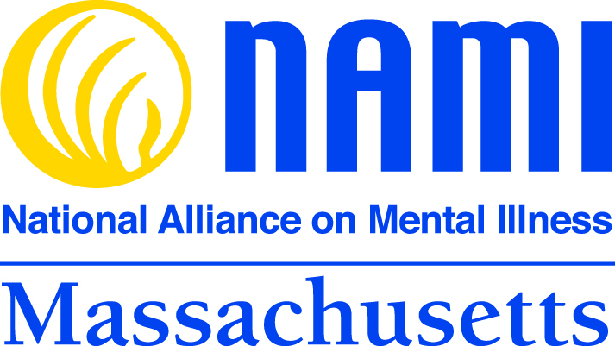

**If you’re interested in taking a class please contact Please contact Rachael Wurtman at rachael.wurtman@gmail.com**