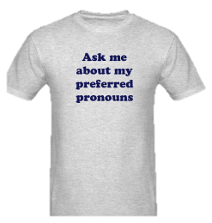
What is a “PGP”?
Loosely speaking, a pronoun is a part of speech that takes the place of other nouns. Some examples of pronouns are: I, we, he, she, all, it, they, their, etc.
Gendered pronouns are those that refer to gender: he, she, him, her, hers, his, himself and herself. Pronouns that do not refer to gender, such as "it," "one," and "they," are gender-neutral or gender-inclusive.

Pronouns may not seem like that big of a deal, but it can be really uncomfortable and/or painful to be mislabeled. A preferred gender pronoun, or PGP, is simply the pronoun or set of pronouns that an individual would like others to use when talking to or about that individual. Most of us make assumptions about peoples’ PGPs all of the time, and sometimes we’re wrong. We don’t do this because we want to make people feel invisible - most of us were simply raised to make these assumptions. However, we can all work on breaking that habit! After all, none of us like to have assumptions made about us. Using PGPs is just another way we can support one another in expressing who we are to the world.

So, how do we avoid making incorrect assumptions about gender pronouns?

One way to make sure that all of our Teen Councils are being inclusive and welcoming for everyone is to incorporate PGPs into our regular intro activities. When we start our year and are learning each other’s names AND when a guest comes to visit our Teen Council, we recommend you start the meeting by having those present share their names and their PGPs. For example: “My name is Melody, I’m a sophomore, and I prefer ‘she’ and ‘her’.” Sometimes a visitor to your group may not have heard about preferred gender pronouns. We want everyone to feel welcome in our groups, including them :-). This can be a great opportunity for someone in the group to practice giving a quick and concise explanation! Remember we want to break the habit of making assumptions about other people’s identities.

If you’re in a more informal setting you can simply ask: " What’s your preferred gender pronoun?"
Recognize that while this might make some people confused, it's also an awesome opportunity to explain why you're asking, and it could really mean something to those who have been mis-identified or care about the issue.

Some people prefer gender-neutral or gender-inclusive pronouns. There are actually many options for gender-neutral pronouns. Different ones are popular in different regions, and they can also change over time. In our crew here in Western Washington, “they”, “them” and “their(s)” are commonly used gender-inclusive pronouns. We’ll practice these in a minute.

An amazing thing about gender-neutral pronouns: we can use them all the time! When we meet someone, we usually don’t know what gender pronouns they prefer. Let’s build it into our Teen Council culture to use gender-neutral pronouns, unless we know for sure that someone prefers a certain gendered pronoun. Then we can all have more fun being human. Hooray!
Example: “Have you met Jay from Pierce County? They’re so awesome!” “No, I haven’t met them. Introduce me?”

RECAP: How do we avoid making incorrect assumptions about gender pronouns?
ASK!
Or, use gender-neutral pronouns, like "they" or "them."
Try this around camp during retreat!

Note: Someone in your group or your life may use different gender-neutral pronouns besides “they/them/their(s)”. Cool! If the pronouns are new to you, find them in the PGP chart attached, and if they’re not on the chart, kindly ask the person to fill their pronouns into a blank row on the chart. Then you can refer back to it or use it to practice. Most people will be happy to take the time to write them down, especially if you let them know that you’re asking because you want to get it right! Many trans* and gender non-conforming people can end up spending a ton of time and energy in their lives coaching people on their preferred pronouns or getting called by pronouns that don’t feel good to them. It can be really exhausting and painful!! Together, we can make Teen Council a place where no one has to feel that way.

A Quick Practice Sesh: They/Them/Their(s)

Using new language always takes practice, and this can be especially true when using these pronouns because many of us are used to using “they” when we’re talking about more than one person. So let’s try it out!

Here are a couple more sample sentences to get us started….
“Chris is the tallest person in class, and they are also the fastest runner.” (Notice how, even though we are only talking about one person, we are still saying ‘they are’).
“Tanzen is going to the beach over break with their parents. I’m so jealous of them.”

- In your pair, each of you will have 1 minute to share about one or more of the people you met during the group journey using the gender neutral pronouns they/them/their(s).
- Start by telling your partner about one person from your group, sharing their name and at least one other thing you learned about them.
- If you still have time, move on to a second person from your journey team.
- If you’d like, you can use the attached Preferred Gender Pronoun Cheat Sheet to help you make your sentences (the ‘they’ row is highlighted for you for this activity).
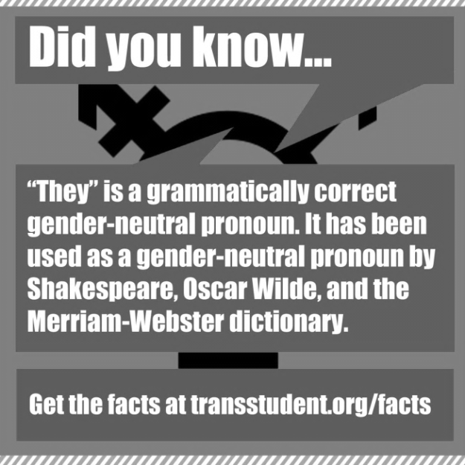
If it takes you the whole time just to get through a couple of sentences, that’s ok! Your efforts mean a lot!

You Can Do It!

